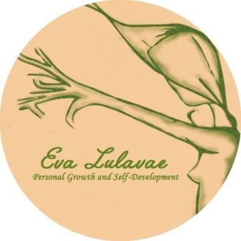

REIKI LEVEL 1 TRAINING REGISTRATION FORM

Date:
Name / Surname:
Address:

Phone:
Email:

Dates:
Venue: Amber Gift Shop, 18 Mary Street na Galway, Ireland
Price: 225€
Early Bird: 195€
To Book, please fill the registration form and send the 100€ deposit receipt to secure your place.

Bank details:
Eva Llado Medina
AIB BANK
BIC AIBKIE2D
IBAN IE58AIBK93709650625183

* Deposits are Non Refundable unless the Workshop is cancelled by Eva Lulavae, Personal Growth and Self-Development

