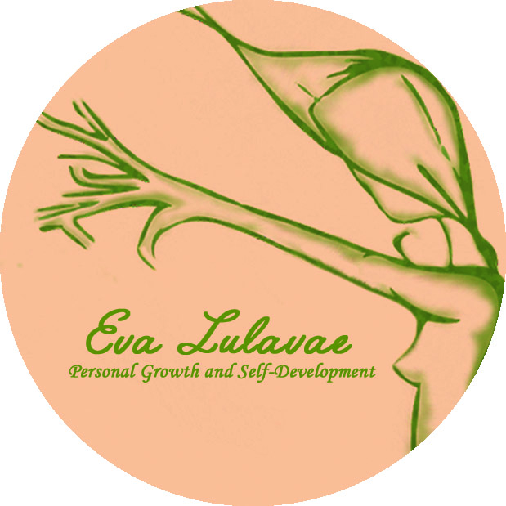

REIKI LEVEL 2 TRAINING REGISTRATION FORM
The requirement to apply to this course is to have completed the first level of Reiki with a Reiki teacher. Please, attach a copy of your First Level certificate with the form.
Date:
Name / Surname:
Address:

Phone:
Email:

Dates:
Venue: Amber Gift Shop, 18 Mary Street na Galway, Ireland
Price: 325€
Early Bird: 295€
To Book, please fill the registration form and send the 100€ deposit receipt to secure your place.

Bank details:
Eva Llado Medina
AIB BANK
BIC AIBKIE2D
IBAN IE58AIBK93709650625183

* Deposits are Non Refundable unless the Workshop is cancelled by Eva Lulavae, Personal Growth and Self-Development

