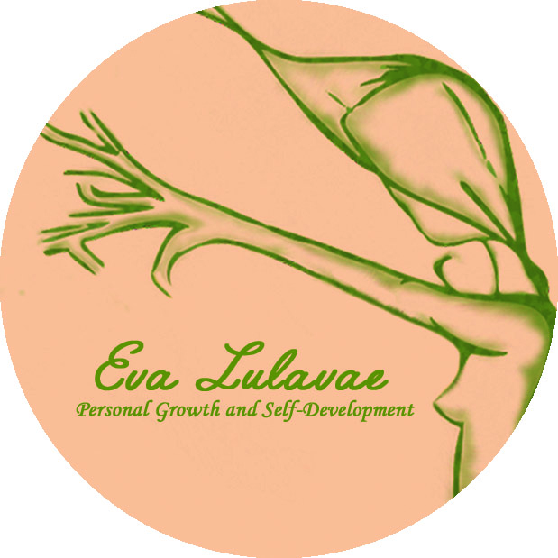

REIKI LEVEL 3 TRAINING REGISTRATION FORM
The requirement to apply to this course is to have completed the Reiki Levels 1, 2 and practitioner with a Reiki teacher. Please, attach a copy of your certificates with the form.
Date:
Name / Surname:
Address:

Phone:
Email:

Dates:
Venue: Amber Gift Shop, 18 Mary Street na Galway, Ireland
Price: 450€
Early Bird: 395€
To Book, please fill the registration form and send the 100€ deposit receipt to secure your place.

Bank details:
Eva Llado Medina
AIB BANK
BIC AIBKIE2D
IBAN IE58AIBK93709650625183

* Deposits are Non Refundable unless the Workshop is cancelled by Eva Lulavae, Personal Growth and Self-Development

