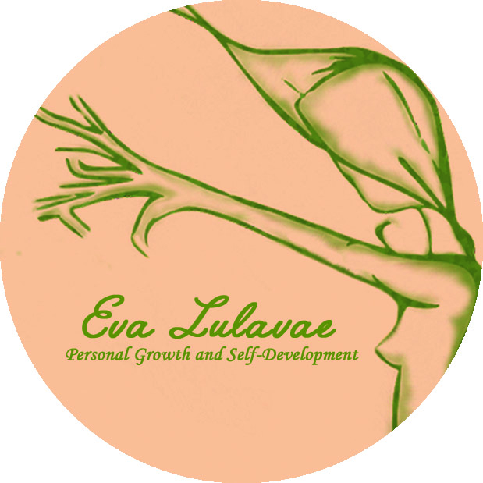

REIKI LEVEL 3 TRAINING REGISTRATION FORM
The requirement to apply to this course for professionals is to have completed the Reiki Levels 1, 2 and Practitioner with a Reiki teacher. Please, attach a copy of your certificates with the form.
The requirement for students for personal growth reasons is to have completed the Reiki Levels 1 and 2 with a Reiki teacher. Please, attach a copy of your certificates with the form.
Date:
Name / Surname:
Address:

Phone:
Email:

Dates: Dates to agreed with the student and an optional assistance to two of the next 3 monthly Reiki Gatherings to do more practice.
Venue: Amber Gift Shop St. Mary’s 18, Galway / Shelley’s Health and Beauty Clinic
Investment: 440€
To Book, please fill the registration form and send the 100€ deposit receipt to secure your place. The rest of the amount (340€) needs to be paid before to start the first day of the course.
Note: Please, due to the amount of applications I receive Students may need to put their names on the bank payment so the payment can be recognised. Thank you.

Bank details:
Eva Llado Medina
AIB BANK
BIC AIBKIE2D
IBAN IE58AIBK93709650625183

* Deposits are Non Refundable unless the Workshop is cancelled by Eva Lulavae, Personal Growth and Self-Development. Filling this form I authorize Eva Lulavae to store and manage my personal data.

