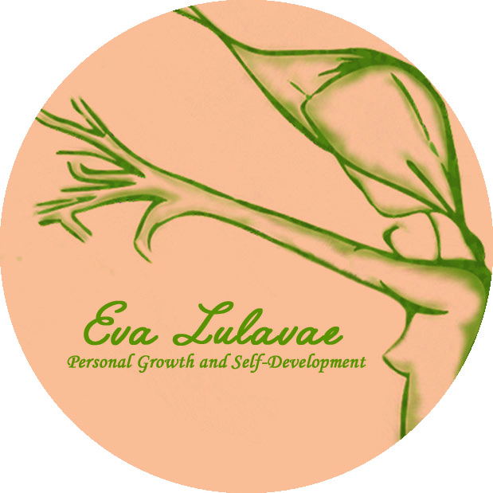

VIOLET FLAME TRAINING REGISTRATION FORM
Date:
Name / Surname: Date of Birth:
Address:

Phone:
Email:

Dates: 31ST of January & 1st of February
Venue: Amber Gift Shop St. Mary’s 18, Galway
Investment: 215€
To Book, please fill the registration form and send the 100€ deposit receipt to secure your place. The rest of the amount (115€) needs to be paid before to start the first day of the course.
Note: Please, due the amount of applications I receive Students may need to put their name on the bank payment so the payment can be recognised. Thank you.

Bank details:
Eva Llado Medina
AIB BANK
BIC AIBKIE2D
IBAN IE58AIBK93709650625183

* Deposits are Non Refundable unless the Workshop is cancelled by Eva Lulavae, Personal Growth and Self-Development. Filling this form I authorize Eva Lulavae to store and manage my personal data.

